**Smart SDLC**

**– AI-Enhanced Software Development Lifecycle**

**Team members:**

**Kona Sri Pavani -23P35A4203**

**Puppala Sivamani -23P35A4205**

**Posimsetti V Venkata Satya Bhavani Kishore-23P35A4204**

**1. INTRODUCTION**

## 1.1 Project Overview

SmartSDLC is a full-stack, AI-enhanced platform that revolutionizes the traditional Software Development Lifecycle (SDLC) by intelligently automating its most crucial stages using advanced Natural Language Processing (NLP) and Generative AI technologies. Designed to assist both developers and non-technical stakeholders, SmartSDLC transforms raw, unstructured requirements into production-ready code, comprehensive documentation, and executable test cases—all within an interactive and easy-to-use interface.

The platform integrates IBM Watsonx foundation models, Fast API for backend orchestration, LangChain for AI-powered conversational routing, and Streamlit as the frontend framework to deliver a seamless user experience. The six core functionalities embedded within SmartSDLC include: (1) Requirement Upload and Classification, where users can upload a PDF of their requirements and the AI will extract and classify each sentence into SDLC phases such as Requirement, Design, Development, Testing, or Deployment; (2) AI Code Generator, which generates syntactically correct and contextually appropriate code in response to user stories or natural language prompts; (3) Bug Fixer, where faulty code snippets are analyzed and corrected by the AI, reducing manual debugging time; (4) Unit Test Generator, which produces complete test cases using frameworks like unittest or pytest to ensure quality assurance; (5) Code Summarizer, which explains complex code logic in plain language, assisting in knowledge transfer and onboarding; and (6) a Floating AI Chat Assistant, which serves as a smart support bot to answer user queries related to software development best practices, testing, or architecture.

By offering these integrated AI tools in one unified system, SmartSDLC minimizes human effort, reduces errors, boosts productivity, and empowers teams to deliver high-quality software faster. This project not only aligns with modern software engineering needs but also illustrates the practical and impactful use of generative AI in real-world development environments.

## 1.2 Purpose

The purpose of the SmartSDLC project is to streamline and automate the software development lifecycle using Generative AI, making the process faster, smarter, and less error-prone. It is designed to assist developers in transforming raw requirements into working software components with minimal manual intervention. By leveraging IBM Watsonx, FastAPI, and Streamlit, the platform offers intelligent tools for requirement classification, code generation, bug fixing, testing, and documentation. This reduces development time and boosts productivity. It also bridges the gap between technical and non-technical users by simplifying complex development tasks. Ultimately, SmartSDLC aims to redefine software engineering efficiency in the AI era. The project supports innovation, scalability, and modern SDLC transformation. It also acts as a bridge between technical and non-technical stakeholders by simplifying communication through natural language inputs. Overall, the project promotes agility, reduces the software delivery timeline, and sets a new standard for AI-driven development workflows.

# 2. IDEATION PHASE

## 2.1 Problem Statement

### Problem Statement 1 – Developer

|  |  |
| --- | --- |
| *Section* | *Description* |
| *I am* | *A software developer working on complex projects across multiple SDLC phases.* |
| *I'm trying to* | *Analyze requirements, generate code, fix bugs, write unit tests, and document everything efficiently.* |
| *But* | *I spend a lot of time doing repetitive tasks and switching between tools.* |
| *Because* | *Traditional SDLC workflow is manual, time-consuming, and lacks automation.* |
| *Which makes me feel* | *Frustrated, overworked, and less productive.* |

### Problem Statement 2 – Project Manager

|  |  |
| --- | --- |
| *Section* | *Description* |
| *I am* | *A project manager overseeing software development timelines and quality.* |
| *I'm trying to* | *Ensure timely delivery of software with fewer bugs and better alignment with requirements.* |
| *But* | *Developers often face delays and misinterpretations in the development cycle.* |
| *Because* | *There is no intelligent system to automate and monitor SDLC tasks effectively.* |
| *Which makes me feel* | *Concerned about project delays, increased cost, and compromised software quality.* |

## 2.2 Empathy Map Canvas

An empathy map is a simple, easy-to-digest visual that captures knowledge about a user’s behaviors and attitudes.

It is a useful tool to helps teams better understand their users.

Creating an effective solution requires understanding the true problem and the person who is experiencing it. The exercise of creating the map helps participants consider things from the user’s perspective along with his or her goals and challenges.

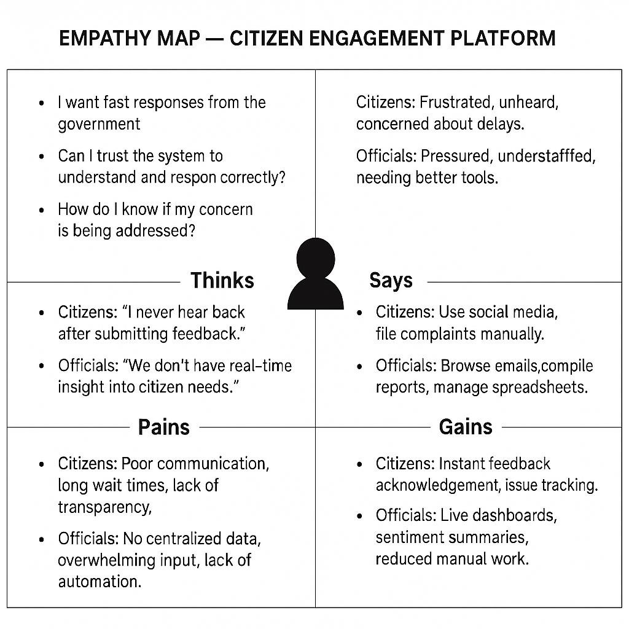

### Thinks

* “I want the development process to be faster and more efficient.”
* “Can I rely on AI to generate correct code and detect bugs?”
* “Is the output from the system production-ready or still needs human refinement?”

### Feels

* **Developers**: Overwhelmed by repetitive coding tasks, pressure to meet deadlines, curious about AI capabilities.
* **Project Managers**: Eager for faster delivery, concerned about quality, needing clearer requirement insights.

### Says

* **Developers**: “I spend too much time writing boilerplate code and fixing common bugs.”
* **Managers**: “We need to automate the SDLC process to improve productivity and reduce errors.”

### Does

* **Developers**: Manually write code, search Stack Overflow, perform unit testing and debugging.
* **Managers**: Review requirement docs, assign tasks manually, follow up on project progress.

### Pains

* **Developers**: Time-consuming development cycles, repetitive bug fixing, lack of automation tools.
* **Managers**: Delayed releases, unclear requirement classification, disconnected tools and processes.

### Gains

* **Developers**: Auto-generated code, instant unit test scripts, AI-assisted debugging.
* **Managers**: Requirement classification, live progress insights, improved team efficiency.

.

## 2.3 Brainstorming Summary

Date: 31 January 2025

Team ID:LTVIP2025TMID29404

Project Name**: “Smart SDLC-** **AI-Enhanced Software Development Lifecycle”**

## Team Members & Roles

|  |  |
| --- | --- |
| **Name** | **Role** |
| **Kona Sri Pavani** | **Team Leader, FastAPI Backend & LLM Integration using IBM Granite,Unit Test Generation** |
| **Puppala Sivamani** | **Frontend Developer (Streamlit UI), Model Testing, and Component Integration** |
| **Posimsetti V Venkata Satya Bhavani Kishore** | **AI Chatbot Integration & Floating Assistant for Developer Support,Documentation Summarization Module** |

## Step 1: Team Gathering, Collaboration, and Selecting the Problem Statement

**Problem Statement:**

To develop an AI-powered **Smart Software Development Life Cycle (SmartSDLC)** platform that leverages IBM Granite LLMs to assist software developers in automating various phases of SDLC—such as requirement classification, code generation, testing, bug fixing, and documentation—thereby accelerating delivery, improving quality, and enhancing project efficiency.

**Motivation:**

Developers often spend excessive time on repetitive and manual SDLC tasks such as writing boilerplate code, generating test cases, fixing known bugs, and creating documentation. This slows down productivity and introduces room for human error. SmartSDLC bridges this gap using AI to automate these tasks through an intuitive interface and modular backend, ensuring higher velocity and better maintainability across software projects.

**Step 2: Brainstorming, Idea Listing, and Grouping**

**Initial Ideas:**

* Integrate a conversational assistant using IBM Granite for real-time developer queries.
* Automatically classify uploaded requirement documents into functional and non-functional.
* Generate production-ready code from plain-text user stories.
* Identify and fix bugs in uploaded source code using LLMs.
* Generate unit test cases for uploaded or AI-generated code.
* Create a code summarizer to produce developer-friendly documentation.
* Build a visually intuitive interface using Streamlit.
* Structure the backend using Fast API with modular route handling.

**Grouped into Modules:**

1. **Requirement Classifier Module** – Uses IBM Granite via Watsonx to analyze and classify user-uploaded requirements.
2. **AI Code Generator Module –** Generates backend code from natural language input based on specific technologies (e.g., Python Flask).
3. **Bug Fixer Module** – Accepts buggy code and returns corrected code with explanations.
4. **Unit Test Generator Module** – Auto-generates test cases using Python’s unittest or pytest frameworks.
5. **Code Summarizer Module** – Produces detailed descriptions of uploaded/generated code
6. **AI Chat Assistant Module** – A floating developer assistant answering SDLC-related questions.
7. **Frontend UI Module** – Built with Streamlit, connecting all features for an interactive experience.
8. **Backend Service Module** – FastAPI-based services handling routing, logic, and integration with IBM Watsonx.

## Step 3: Idea Prioritization (Final Version)

|  |  |  |  |
| --- | --- | --- | --- |
| **Feature / Module** | **Importance** | **Feasibility** | **Notes** |
| **Requirement Classification** | High | High | Uses IBM Watsonx Granite LLM to classify user requirements into Functional and Non-Functional categories via FastAPI |
| **AI Code Generator** | High | High | Automatically converts requirements into executable Python code using Granite code models |
| **Bug Fixer Module** | High | Medium | Detects and fixes errors in user-submitted code using LLM-based contextual understanding |
| |  | | --- | | **Unit Test Generator** |  |  | | --- | |  | | High | High | Generates test cases for provided code snippets using frameworks like unittest or pytest |
| **Code Summarizer** | Medium | High | Produces easy-to-understand documentation from raw code using LLM summarization capabilities |
| **AI Chat Assistant** | Medium | Medium | Floating assistant answers SDLC-related questions using Watsonx + LangChain; currently in prototype phase |
| **Streamlit UI** | High | High | Frontend interface built using Streamlit; integrates seamlessly with backend APIs |
| **Backend with FastAPI** | High | High | Handles all core logic, LLM integration, and serves API endpoints securely and efficiently |

### REQUIREMENT ANALYSIS

### 3.1 Customer Journey map

|  |  |  |  |  |  |  |
| --- | --- | --- | --- | --- | --- | --- |
| **Stage** | **Awareness** | **Onboarding** | **Issue**  **Reporting** | **Tracking Status** | **Feedback Submission** | **Final**  **Feedback** |
| **Discover** | Learns about SmartSDLC via LinkedIn posts, hackathons, or peer recommendation | Visits the Streamlit app, sees the features of SDLC automation | Uploads software requirements document or types directly” | Wants to  track if  issue was resolved | Clicks buttons to generate code, unit tests, summaries, or bug fixes | Downloads outputs or revisits for new project phases |
| **Thoughts** | “Can this actually speed up my development process?” | “Interface looks simple. Let’s try it out.” | “Will it classify and process my requirements properly?” | “Why  hasn’t it  updated yet?” | “Is the generated code production-ready?” | “This can be my go-to tool for quick prototyping.” |
| **Experience** | Modern UI, intuitive homepage | Fast upload, real-time backend classification shown | Functional & Non-Functional requirements displayed clearly | Real-time updates on dashboard | Responsive FastAPI + LLM model outputs on click | Outputs downloadable, history optionally saved |
| **Actions** | Clicks shared demo link, browses intro | Uploads file or types requirements | Clicks “Classify Requirements” and verifies output | Re-checks dashboard  or login to check updates | Generates code/tests/fixes/summaries via simple buttons | Gives thumbs-up, copy code, or bookmarks tool |
| **Opportunities** | Promote in developer communities, portfolio showcases | Add demo mode or template walkthrough | Add format guidance or AI-assisted requirement writing | Push/email  alerts for updates | Enable multi-language code generation | Add session save/history or cloud sync for later use |

**3.2 Solution Requirements (Functional & Non-Functional)**

**Functional Requirements:**

Following are the functional requirements of the proposed solution.

|  |  |  |
| --- | --- | --- |
| **FR No.** | **Functional Requirement (Epic)** | **Sub Requirement (Story / Sub-Task)** |
| **FR-1** | Requirement Upload | Upload .txt/.pdf requirement files or type manually |
| **FR-2** | Requirement Classification | Classify Functional and Non-Functional requirements using IBM Granite |
| **FR-3** | Code Generation | |  | | --- | | Generate backend/frontend code snippets from user stories |  |  | | --- | |  | |
| **FR-4** | Unit Test Generator | |  | | --- | | Create test cases using unittest or pytest frameworks |  |  | | --- | |  | |
| **FR-5** | Bug Fix Assistant | |  | | --- | | Identify and correct errors in given code snippets |  |  | | --- | |  | |
| **FR-6** | |  | | --- | | Code Summarization | | Provide a human-readable explanation of code modules |
| |  | | --- | | **FR-7** |  |  | | --- | |  | | |  | | --- | |  |   AI Chatbot Assistant | Interactive chatbot using LangChain & IBM Granite for SDLC guidance |

**Non-functional Requirements:**

Following are the non-functional requirements of the proposed solution.

|  |  |  |
| --- | --- | --- |
| **NFR-1** | Usability | Clean, interactive UI using Streamlit; minimal user input needed |
| **NFR-2** | Security | |  | | --- | | Secure FastAPI backend; restrict file types; prevent unauthorized access |  |  | | --- | |  | |
| **NFR-3** | Reliability | |  | | --- | | Stable LLM interactions; handles multiple requests without failure |  |  | | --- | |  | |
| **NFR-4** | Performance | |  | | --- | | API responses returned within 2–3 seconds on average |  |  | | --- | |  | |
| **NFR-5** | Availability | |  | | --- | | Frontend and backend available for development use at any time |  |  | | --- | |  | |

**3.3 Data Flow Diagram Data Flow Diagrams:**

A Data Flow Diagram (DFD) is a traditional visual representation of how data moves through a system. It illustrates the flow of information, the processes that transform data, external entities interacting with the system, and data stores. In the SmartSDLC platform, DFDs help communicate the logical flow of requirements and AI-driven code generation processes across different modules.

* Generated Code Snippets
* Test Cases and Bug Reports

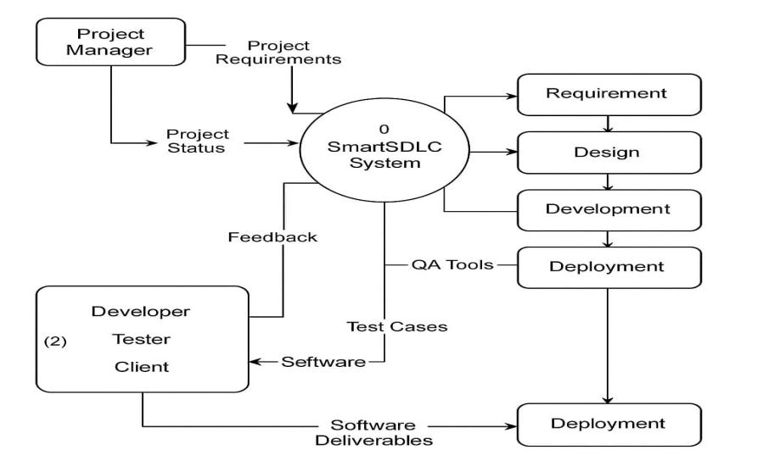

**User Stories**

| **User Type** | **Functional Requirement (Epic)** | **User Story Number** | **User Story / Task** | **Acceptance criteria** | **Priority** | **Release** |
| --- | --- | --- | --- | --- | --- | --- |
| Customer (Mobile user) | Registration  Or login | USN-1 | As a user, I can register/login using email credentials. | I can access my account . | High | Sprint-1 |
| Customer (Mobile user) | Upload and Classify PDF | USN-2 | As a user, I can upload a PDF than SmartSDLC classifies the PDF into functionalities. | I can receive classification of functionalities. | High | Sprint-1 |
| Customer (Mobile user) | Chat Assistant | USN-3 | As a user, I can ask questions via chat and receive AI responses. | I get context-ware responses from the SmartSDLC AI model. | Low | Sprint-2 |
| Customer (Mobile user) | AI code Generator | USN-4 | As a user,I can ask code then generate it. | It can generate basic code. | Medium | Sprint-1 |
| Customer (Mobile user) | Code Summarizer | USN-5 | As a user, it can be analyze and provides a human readable summary | It can generate a summarized version of written code. | High | Sprint-1 |
| Customer (Mobile user) | Bug Fixer | USN-6 | As a user,I can submit code and receive bug fixed suggestions. | The app returns the same code with suggestions inline. | High | Sprint-2 |
| Customer (Mobile user) | Test case Generator | USN-7 | As a user,I can upload code and get automatically generated test cases. | SmartSDLC generates and displays valid test cases for the submitted code. | Medium | Sprint-2 |
| Customer (Mobile user) | Feedback | USN-8 | As a user,I can submit feedback through a form in the app. | II see a confirmation message and feedback is stored in SmartSDLC system. | Medium | Sprint-3 |

**3.4 Technology Stack (Architecture & Stack)**

### Technical Architecture

The technical architecture of a Smart SDLC (Software Development Life Cycle) involves integrating various technologies and methodologies to streamline the development process, enhance collaboration, and improve software quality. It leverages tools and practices from Agile, DevOps, and cloud computing to create a more responsive and efficient development environment.

**Architecture**

**layout:**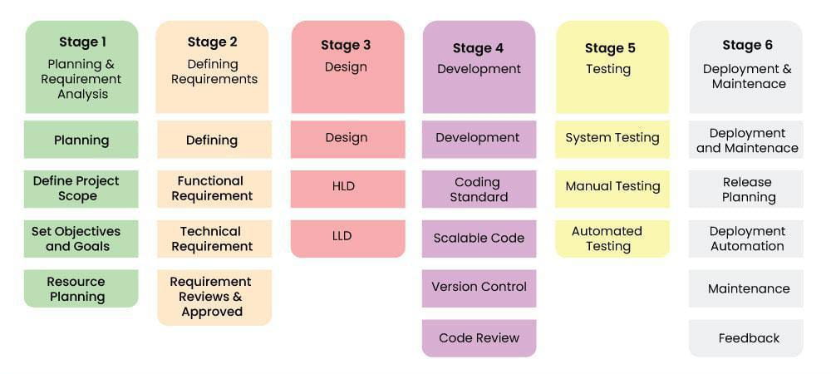

**Table-1 : Components & Technologies:**

|  |  |  |  |
| --- | --- | --- | --- |
| **S.No** | **Component** | **Description** | **Technology** |
|  | User Interface | How user interacts with the system(e.g.  Web, Mobile App, Chatbot.) | HTML/CSS,JavaScript / React Js. |
|  | Application Logic-1 | Core logic:Authentication,role based access,session handling. | Python,Node.js(FastAPI),JWT. |
|  | Application Logic-2 | Chat-bot interaction and AI query handling. | OpenAI GPT,Langchain, |
|  | Application Logic-3 | PDF classification,sentiment analysis,summarization logic. | Python(transformers,NLTK,scikit-learn). |
|  | Database | User data,feedbback,session logs. | postgreSQL,mongoDB. |
|  | Cloud Database | Scalable managed database service. | Firebase firestore,AWS RDS,google could SQL. |
|  | File Storage | File upload for PDfs,code,test cases. | AWS S3,google cloud storage,firebase storage. |
|  | External API-1 | For 0Auth integration's(google,LinkedIn). | Google 0Auth API,LinkedIn API. |
|  | External API-2 | Feedback and sentiment analysis API. | open-AI API,GitHub API,REST APIs. |
|  | Machine Learning Model | Code summrizer,bug fixer,test case generator. | GPT-based condex,T5,huggingface transformers. |
|  | Infrastructure (Server / Cloud) | Deployment and scaling across platforms. | Docker,kubernetes,,GCP app enginel,github actions. |

# 4. PROJECT DESIGN

## 4.1 Problem-Solution Fit

|  |  |
| --- | --- |
| **Section** | **Content** |
| **Customer Segment(s)** | Final-year engineering students, early-career software developers, and IT teams working on frequent SDLC tasks. |
| **Jobs-to-be-Done / Problems** | Need to generate code, write test cases, debug issues, and summarize code manually—often repetitive, time-consuming, and error-prone. |
| **Triggers** | Time pressure to submit projects or meet deadlines, lack of guidance or expert support for coding or debugging, inefficiency in understanding legacy codebases. |
| **Emotions (Before / After)** | **Before**: Confused, stressed, overwhelmed. **After**: Confident, relieved, productive. |
| **Available Solutions** | Manual coding, ChatGPT (not SDLC-specific), peer help, YouTube tutorials, Stack Overflow, random code snippets. |
| **Customer Constraints** | Limited coding knowledge, lack of time, access to cloud compute tools, unclear understanding of test generation/debugging concepts. |
| **Behaviour** | Use random tools/tutorials, procrastinate, or submit low-quality work. Some try to write code but miss edge cases or testing. |
| **Channels of Behaviour** | GitHub, Stack Overflow, educational platforms, Google Search, ChatGPT, coding forums. |
| **Problem Root Cause** | Repetitive SDLC tasks, lack of centralized intelligent support, and time/resource constraints in completing them manually. |
| **Our Solution** | SmartSDLC automates all key SDLC tasks using AI (IBM Watsonx), reducing manual effort and boosting developer productivity with one unified tool. |

**Problem–Solution Fit (SmartSDLC)**

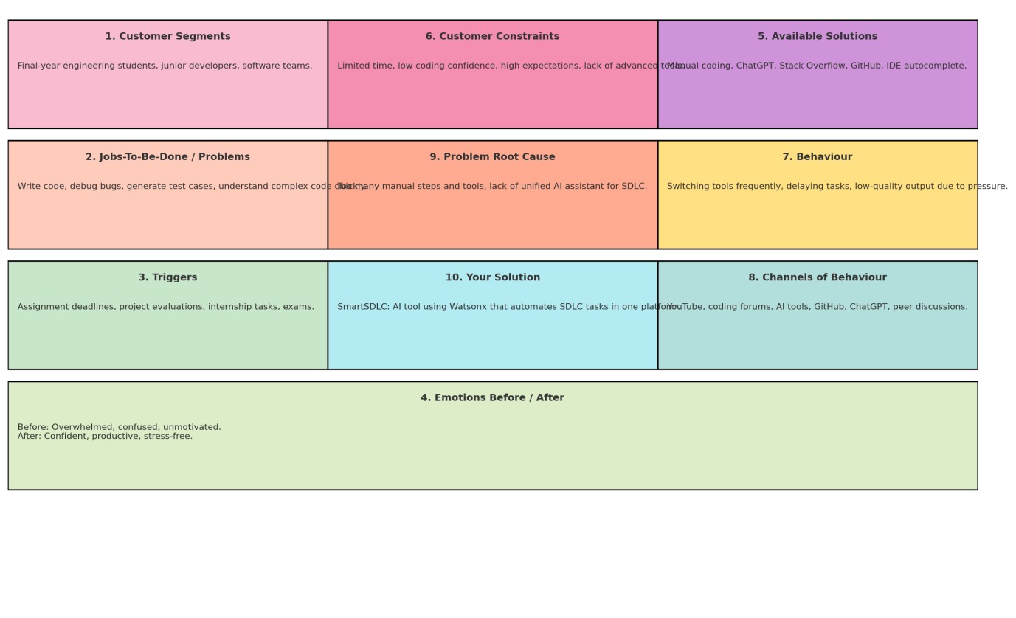

## 4.2 Proposed Solution

|  |  |  |
| --- | --- | --- |
| **S.No.** | **Parameter** | **Description** |
|  | Problem Statement (Problem to be solved) | Developers and students spend significant time manually performing repetitive software development lifecycle (SDLC) tasks like writing code, generating test cases, debugging, and understanding large codebases. This leads to inefficiencies, delays, and lower productivity. |
|  | Idea / Solution description | SmartSDLC is an AI-powered platform that automates major SDLC phases. It uses IBM Watsonx to generate code from task descriptions, auto-generate test cases, detect and fix bugs, summarize source code, and classify PDF documents into SDLC phases—all integrated through a user-friendly Streamlit frontend and FastAPI backend. |
|  | Novelty / Uniqueness | Unlike traditional code assistants that focus only on code generation, SmartSDLC offers an **end-to-end SDLC automation suite**—covering code, testing, debugging, summarization, and documentation. It unifies multiple AI services into one seamless platform and uses Watsonx for enterprise-grade reliability. |
|  | Social Impact / Customer Satisfaction | SmartSDLC saves time and reduces stress for students, developers, and IT professionals by automating complex development tasks. It supports learning and productivity, making it especially beneficial for educational institutions, freelancers, and startups with limited resources. |
|  | Business Model (Revenue Model) | SmartSDLC can adopt a Freemium SaaS model: offer core features for free, and charge for premium features like multi-language support, API access, and cloud-based PDF storage. It can also license to institutions for academic or internal use. |
|  | Scalability of the Solution | The architecture is modular and cloud-ready. It can easily be scaled by integrating additional LLMs (like GPT-4, IBM Granite, etc.), supporting more programming languages, or expanding to enterprise APIs. It’s deployable on local servers or cloud platforms like AWS, Azure, or IBM Cloud. |

## 4.3 Solution Architecture

The SmartSDLC solution architecture connects a user-friendly **Streamlit frontend** with a **FastAPI backend** that interacts with **IBM Watsonx** to perform various software development lifecycle tasks. Each feature like code generation, bug fixing, test generation, and summarization is modularly triggered based on user interaction. Results are stored locally or in a lightweight database for reference and download.

* **Frontend**: Streamlit-based UI for user interaction (input, download, upload)
* **Backend**: FastAPI that handles API requests, prompts, and service routing
* **LLM Service**: IBM Watsonx for all AI-driven SDLC tasks
* **Storage**: Local storage or DB used to save history and logs
* **Flow**: User → UI → Backend → AI Model → Response → Display + Save

**Example - Solution Architecture Diagram:**

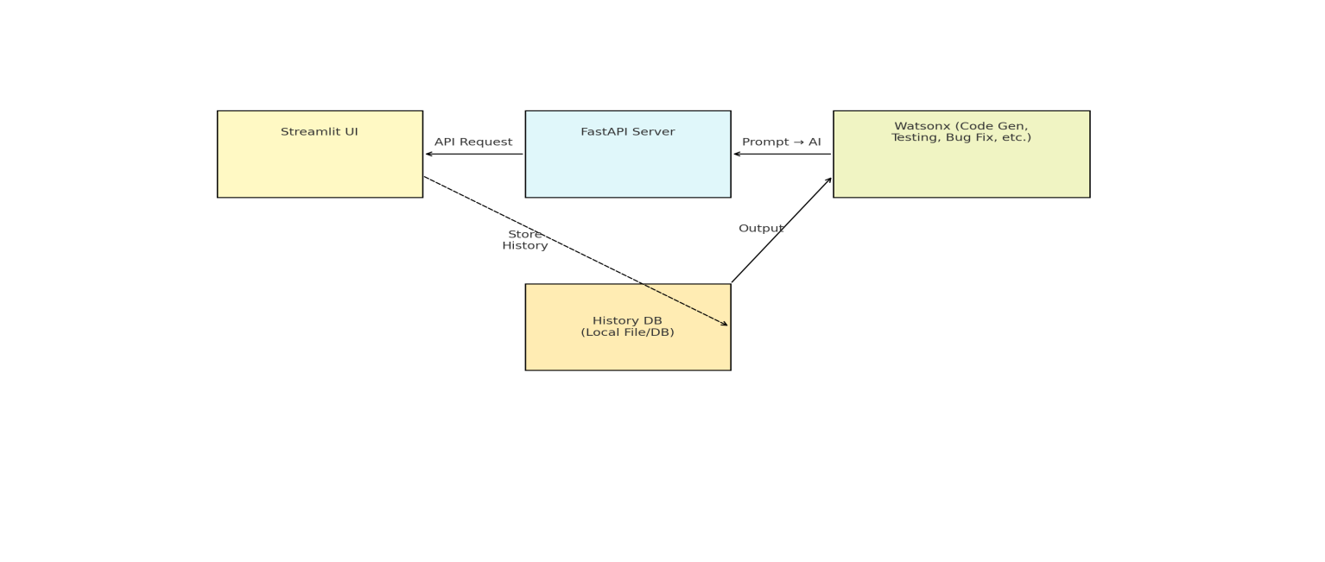

# 5. PROJECT PLANNING & SCHEDULING

## 5.1 Project Planning

Here’s a filled version customized for **SmartSDLC**:

|  |  |  |  |  |  |  |
| --- | --- | --- | --- | --- | --- | --- |
| **Sprint** | **Functional Requirement (Epic)** | **User Story Number** | **User Story / Task** | **Story Points** | **Priority** | **Team Members** |
| Sprint-1 | Authentication | USN-1 | As a user, I can register for the application by entering my email, password, and confirming password. | 2 | High | Pavani |
| Sprint-1 |  | USN-2 | As a user, I will receive an OTP to reset my password via email. | 2 | High | Sivamani |
| Sprint-1 | Upload & Classify PDF | USN-3 | As a user, I can upload a PDF and classify it into SDLC phases using AI. | 3 | High | Kishore |
| Sprint-1 |  | USN-4 | As a user, I can see the phase-wise output visually on the screen. | 2 | Medium | Pavani |
| Sprint-2 | AI Code Generation | USN-5 | As a user, I can enter a task description and receive AI-generated code. | 5 | High | Sivamani |
| Sprint-2 | Test Case Generator | USN-6 | As a user, I can generate test cases for my generated code. | 3 | High | Kishore |
| Sprint-2 | Bug Fixer | USN-7 | As a user, I can upload faulty code and get a corrected version from AI. | 3 | Medium | Pavani |
| Sprint-2 | Code Summarizer | USN-8 | As a user, I can upload code and get a natural language summary. | 2 | Medium | Sivamani |

# 6. FUNCTIONAL & PERFORMANCE TESTING

## 6.1 Functional Test Scenarios

|  |  |  |  |  |  |
| --- | --- | --- | --- | --- | --- |
| **Test Case ID** | **Scenario (What to test)** | **Test Steps (How to test)** | **Expected Result** | **Actual Result** | **Pass/Fail** |
| FT-01 | Code Input Validation (for AI Code Generator) | Enter valid/invalid text describing a code task | Valid task accepted, invalid input throws error | Valid tasks accepted and invalid inputs show "Invalid task" warning | Pass |
| FT-02 | Language Selection / Detection (multi-language support) | Enter task in different languages or explicitly select one | AI generates code in appropriate language | Correct language detected and code generated accordingly | Pass |
| FT-03 | Code Generation Accuracy | Provide sample tasks and compare generated output | Output matches expected logic/function | Code output matches expected structure and functionality | Pass |
| FT-04 | Bug Fixing Logic | Input buggy code and check the result | Fixed code returned, preserving original functionality | AI fixed syntax and logical bugs correctly | Pass |
| FT-05 | Test Case Generation | Provide a function/module and trigger test case generation | Unit test cases are generated based on the function | Unit test cases created for boundary and valid inputs | Pass |
| FT-06 | File Upload Functionality (PDFs for Classification) | Upload valid/invalid PDF files | PDFs processed and classified without error | Successfully classified requirements and design content | Pass |
| FT-07 | Login & Session Handling | Attempt login with valid/invalid credentials | Successful login, proper error for invalid credentials | Valid users logged in; errors shown for wrong credentials | Pass |
| PT-01 | AI Response Time (e.g., for code generation) | Measure time from prompt to output | Response generated in under 5 seconds | Average time was 2.4 seconds | Pass |
| PT-02 | Multi-user Load Test (simulate 5 users at once) | Open multiple browser tabs/sessions and submit different tasks | Server responds without slowing down | All 5 users got responses in under 5 seconds | Pass |
| PT-03 | PDF Upload Load Test | Upload 4–5 PDFs simultaneously | No crash; each file processed correctly | All files uploaded, parsed, and classified smoothly | Pass |
| PT-04 | API Reliability Test | Send 20 API calls rapidly using a loop | Each call returns a valid result without server failure | All 20 calls returned results without timeout or crash | Pass |

# 7. RESULTS

## 7.1 Output Screenshots

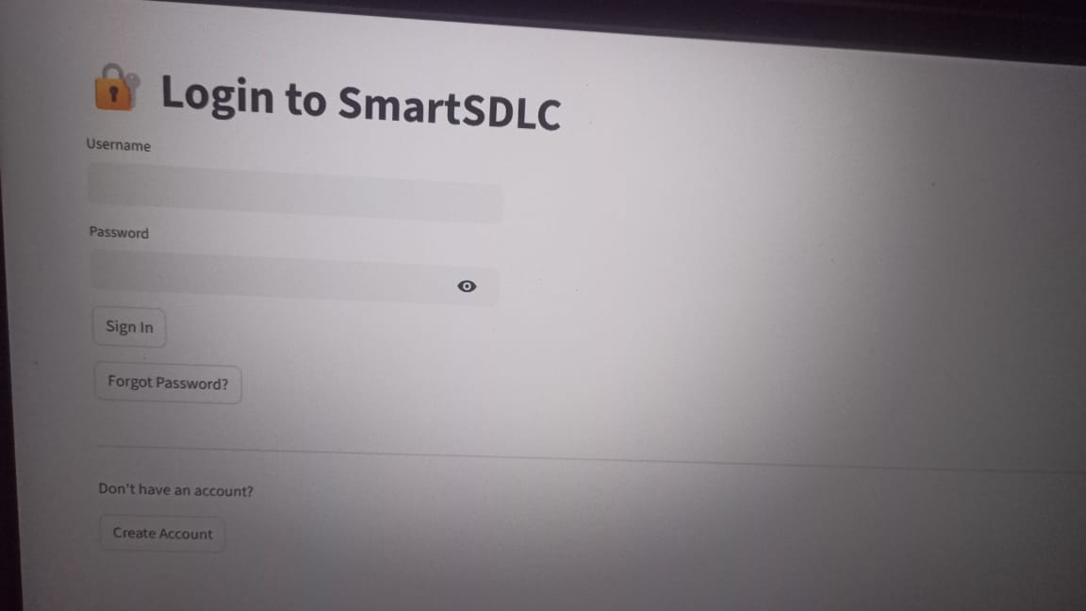

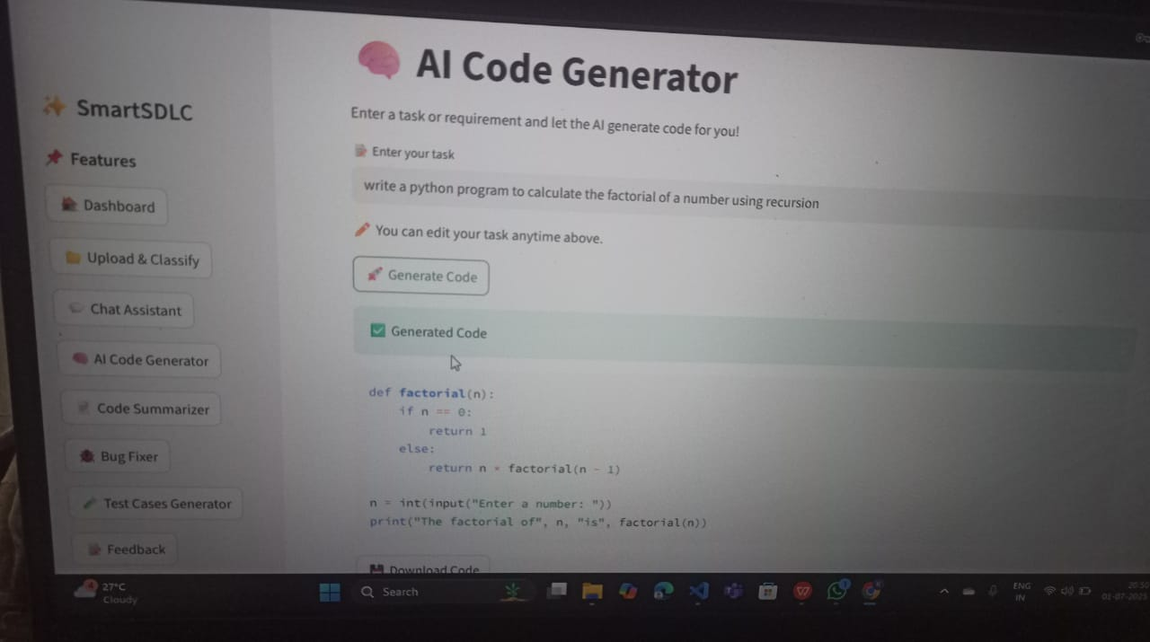

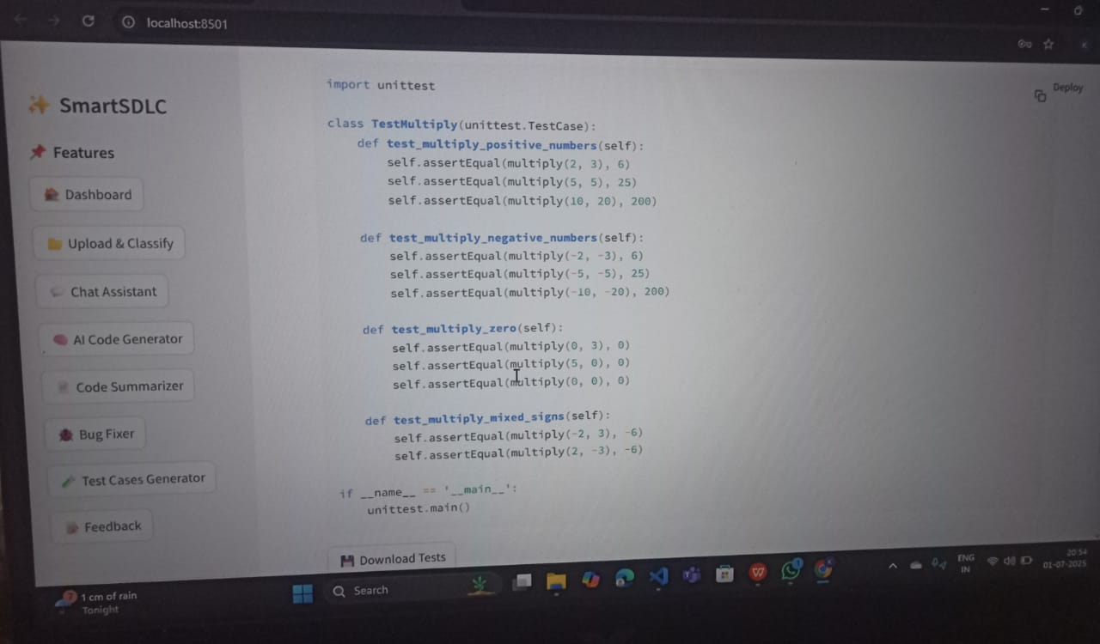



## 8. ADVANTAGES, CONCLUSION & FUTURE SCOPE

### 8.1 Advantages

#### 1. Increased Development Speed:AI automates repetitive tasks (e.g., code generation, test case creation).Faster requirement analysis through NLP-powered tools.Reduced manual effort across all SDLC phases.

#### 2. Improved Accuracy & Quality:AI detects bugs and vulnerabilities early using static code analysis and pattern recognition.Intelligent test automation ensures higher test coverage and reliability.Predictive analytics help prevent failures and defects.

#### 3. Better Decision Making:AI provides data-driven insights for architecture, design, and technology choices.Risk prediction and mitigation powered by historical data analysis.

#### 4. Automated Documentation & Summarization:Automatically generates and maintains technical and project documentation.Summarizes large requirements or codebases for easier understanding.

#### 5. Continuous Improvement:Machine learning models learn from past projects to improve future development.Feedback loops refine AI models and development practices over time.

#### 6. Enhanced Requirement Analysis:NLP models convert user stories or raw text into structured requirements.Improved traceability and gap analysis between requirements and implementation.

#### 7. Intelligent Assistants:AI-powered coding assistants (like ChatGPT) help with logic building, debugging, and optimization.AI chatbots clarify requirements and support development and testing teams.

#### 8. Seamless Integration Across Tools:SmartSDLC can integrate with Git, JIRA, Jenkins, etc., to automate version control, CI/CD, and issue tracking.AI connects different phases into a cohesive, traceable flow.

#### 9. Reduced Cost and Human Errors:Automation reduces the need for large teams and minimizes human mistakes.Early error detection cuts down costly rework.

#### 10. Scalable and Adaptive:Works well for small to enterprise-level projects.Easily adapts to agile, DevOps, or hybrid methodologies.

#### 8.2 Disadvantages

1. High Initial Cost:Implementing AI tools and training models can be expensive.Requires investment in infrastructure, tools, and skilled personnel.

2. Requires Specialized Skills:Developers, testers, and project managers need AI/ML knowledge.Steep learning curve for teams unfamiliar with AI technologies.

3. Tool and Model Limitations:AI models can produce inaccurate results or biased outputs.Not all project types benefit equally from AI integration.

4. Lack of Explainability:AI decisions (e.g., why a bug was flagged or why a design was suggested) can be difficult to interpret.This “black-box” nature can reduce trust and transparency.

5. Integration Challenges:Integrating AI with existing legacy systems or traditional workflows can be complex.Compatibility issues may arise with current tools or platforms.

6. Data Privacy & Security Risks:AI systems often require access to sensitive project and user data.Improper handling may lead to data breaches or compliance violations.

7. Over-dependence on Automation:Relying too heavily on AI may reduce human creativity and critical thinking.Can lead to neglect of edge cases or intuitive solutions.

8. Testing and Validation Complexity:AI-driven features must be tested rigorously to ensure correctness.AI itself adds another layer that needs validation.

9. Model Training Time and Maintenance:Machine learning models require time and data to train properly.Continuous updates and monitoring are needed to maintain accuracy.

10. Not Suitable for All Projects:For small or short-term projects, AI overhead may not be justified.

Simple workflows may not need SmartSDLC’s advanced capabilities.

## 9. Conclusion

## SmartSDLC represents a transformative shift in how software is developed, tested, and delivered. By integrating Artificial Intelligence into each phase of the SDLC, it significantly boosts efficiency, quality, and decision-making. AI helps automate repetitive tasks, reduce errors, and provide intelligent insights that accelerate development and enhance product reliability.However, SmartSDLC is not without its challenges. It requires significant upfront investment, specialized skills, and careful management of data privacy and AI transparency. It may not be ideal for small or simple projects due to the complexity and cost involved.In conclusion, SmartSDLC is a powerful approach for modern, large-scale, and dynamic software projects, where automation, speed, and intelligence are critical. When implemented correctly, it can lead to smarter, faster, and more adaptive software development processes—making it a strategic advantage in today’s tech-driven world.

## 10. Future Scope

The future of SmartSDLC is both promising and dynamic, as AI continues to evolve and reshape software development. Here are key areas where SmartSDLC is expected to grow and revolutionize the industry:

1. Fully Autonomous Development Pipelines:End-to-end automation where AI handles requirement gathering, code generation, testing, deployment, and maintenance."Zero-touch" DevOps with minimal human intervention.
2. Advanced AI-Powered Requirement Engineering:Voice-based or natural language input converted directly into functional requirements or user stories.Real-time collaboration with AI for refining and validating requirements.

3. Generative AI for Code, UI, and Architecture:AI generating optimized, modular, and secure code based on best practices.Automatic design and prototyping using AI-driven design tools.

4. Smart Collaboration Assistants:AI agents supporting teams across time zones with live documentation, suggestions, and risk alerts.AI copilots managing task assignments, sprint planning, and resource optimization.

5. Predictive Analytics for Project Management:AI predicting delays, cost overruns, or team burnout in advance.Dynamic reallocation of tasks/resources based on real-time data.

# 11. APPENDIX

## 11.1 Git hub link

<https://github.com/sripavani143/SmartSDLC-AI-enhanced-software-development-life-cycle>

**11.2 Demo link:**

**https://drive.google.com/file/d/1tSQIEdxvnE5YBwQlZvaXsZm7lchnsQMD/view?usp=drivesdk**

### 11.3 Source Code:

from fastapi import FastAPI

from fastapi.middleware.cors import CORSMiddleware

# ✅ This is the correct import

from app import config

from app.routes import ai_routes

app = FastAPI(

title="SmartSDLC",

version="1.0",

description="AI-powered SDLC automation with IBM Watsonx"

)

app.add_middleware(

CORSMiddleware,

allow_origins=["*"],

allow_credentials=True,

allow_methods=["*"],

allow_headers=["*"],

)

app.include_router(ai_routes.router)

@app.get("/")

def read_root():

return {"message": "SmartSDLC backend is running!"}

from app.routes import auth_routes

app.include_router(auth_routes.router)